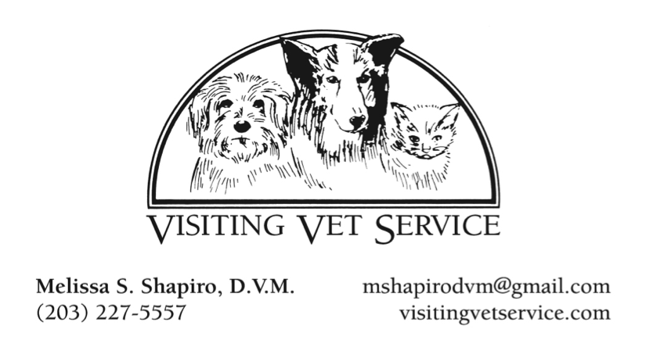
and Laser Therapy for Pets

LASER THERAPY FOR PETS

My Visiting Vet Service offers full service veterinary care to dogs and cats in all stages of life, with a special interest in senior, disabled, and special needs pets. Recently, I’ve been exploring different avenues to expand services for my senior and special needs patients. Since many have orthopedic issues and end up being treated with ongoing daily medications, laser therapy kept coming up in my search for new options for these old, arthritic, and painful seniors.
Low Level Class IV Cold Laser Therapy is used to treat various types of inflammation and pain. The Cutting Edge laser system uses two different wavelengths in a continuous and pulsed wave simultaneously through one hand-piece. The wavelengths used (808 and 905) improve blood flow and circulation, and lymphatic flow, which result in decreased swelling, inflammation, and pain.

This type of laser therapy is a non-invasive and non-painful treatment alternative for dogs and cats with a variety of conditions. In addition to treating arthritis, disc disease, other orthopedic injuries, and post surgical sites (ACL), the laser is also effective in treating open wounds, inflammatory skin lesions, stomatitis (mouth), anal gland abscesses, feline urinary obstructions, and ear infections. It can be used intra-operatively, and is helpful in cases where surgery and medications are not an option.

The treatments are quick, painless, and affordable. While not all dogs respond dramatically to the laser, many show significant improvement in range of motion, swelling, and comfort level after just one or two treatments. Most acute conditions will respond in 1-3 visits, while it takes about 6 treatments over 3 weeks to get an optimal response for chronic orthopedic conditions. Then treatment intervals are increased to every few weeks as needed for maintenance. For this reason, laser therapy is commonly sold in packages of 3 or 6 treatments.

In home treatments work very well for older dogs and cats that don’t travel well anymore. These pets tend to relax and enjoy the therapy on a couch or favorite bed. In hospital treatments are available at Norwalk Vet Hospital for families that would prefer to bring their pets there. Laser therapy is also available at a convenient, comfortable location in Westport.

For more information, please contact Dr. Shapiro.

